10 | 20 | 30
40 | 50 | 60
70 | 80 | 90
100 | STO | 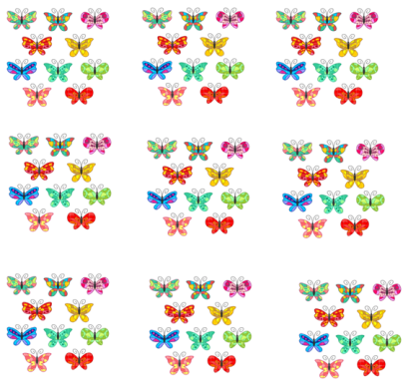
OSEMDESET | SEDEMDESET | 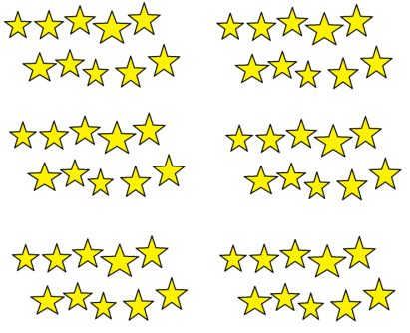
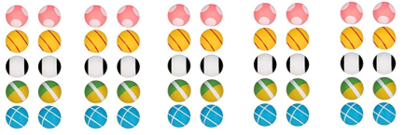 | ŠTIRIDESET | 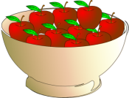  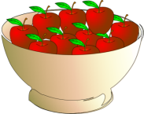  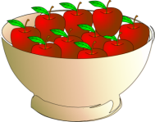
DVAJSET | 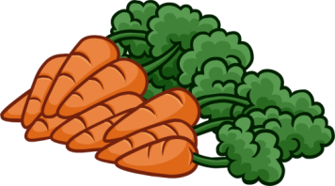

Viri slik:

http://clubpenguin.wikia.com/wiki/Bunch_of_10_Carrots
http://www.clker.com/clipart-bowl-10-apple.html
http://www.amazon.in/Artengo-Artengo-800-C-X-10-800-C-X-10-Balls/dp/B009NHFKHE
http://leotardsandscrunchies.blogspot.si/
http://semiexclusiveart.com/product/colorful-butterflies-set-semi-exclusive-clip-art-set-for-digitizing-and-more/

